RCSLT Stammering summary

## DRAFT FOR CONSULTATION

April 2025

Information contained within this document is for consultation only and should not be shared outside of this.

**The information in this document is currently in development and has been shared as part of a consultation. If you are seeking guidance or information on this topic, please ensure you refer to final published content which can be found on rcslt.org.**

We appreciate any comments provided to us during the consultation, all of which will be reviewed by the working group within the context and scope of the project. We ask that, where possible and relevant, you accompany any counter arguments to statements made in the document with supporting evidence e.g. a research reference.

Members of the working group should not be contacted directly, and all feedback should be made through the assigned route e.g. via survey or project manager. Feedback made through unassigned routes or after the closing date will not be accepted or responded to.

Thank you for your support with this project.

Lorna Baxter, Senior Project Manager

[lorna.baxter@rcslt.org](mailto:lorna.baxter@rcslt.org)

This page provides an overview of stammering and how it relates to speech and language therapy.

Practice recommendations for speech and language therapists working with/in stammering can be found here [add link].

See resources page [add link] for useful resources relating to learning, research and policy in the field of stammering.

Please [contact us](https://www.rcslt.org/help-and-support/contact-us) if you have any suggestions or feedback on these pages.

# Terminology

The terms *stammering, stuttering* and *dysfluency* can be used inter-changeably. The term *dysfluency* is deficit based and implies that deviation from the “norm” is a problem. *Stammering* or *stuttering* acknowledge the lived experience without implying that variation is inferior. Within the UK, *stammering* is the term most used by organisations that provide support to this group of people. *Stammering* will be the term used within this guidance.

# Summary

Stammering is a variation in speech. It is complex in terms of its causes as well as the ways in which it impacts people in their everyday lives. Research indicates that stammering has neurophysiological causes with subtle differences in the brain regions and connectivity pathways which support fluent speech production. Stammering may also have a genetic cause with it commonly running in families. Factors such as childhood speech and language development, biological sex and temperament may exert some influence on whether stammering is more likely to disappear over time or continue. Typically, stammering begins in childhood, although in some cases it may emerge during adolescence or adulthood, usually due to neurological, psychological or pharmacological changes.

People who stammer often experience negative thoughts and feelings about speaking, which may be due to reactions received from others and attitudes to stammering prevalent within society, or the person's internal response to the sensation of feeling 'stuck' when trying to speak due to reactions received from others and attitudes to stammering prevalent within society. They may develop coping strategies, such as avoiding difficult words or situations. Some people experience a widespread negative impact, affecting their mental health, self-image, choices around education/career/lifestyle and can lead to them speaking less in many areas of their life.

Speech and language therapists (SLTs) play a role in offering support and therapy for children, young people, and adults who stammer. They support individuals to be the best communicator they can be whether or not they are stammering. SLTs work directly with individuals and their families while also collaborating with others to foster a more supportive and accepting communication environment.

# Overview

This overview provides information for speech and language therapists working with people who stammer. Feedback from people who stammer and their families has been considered in the writing of this guidance.

### 3.1 What is stammering?

The terms stammering and stuttering are used interchangeably. In this guidance the term stammering is used.

Stammering is a variation in speech that has no single definition. However, there is agreement about its complex, multidimensional nature. (Packman & Kuhn, 2009; Ward, 2018). People who stammer have defined their experience of stammering as a sense of loss of control with affective, behavioural and cognitive reactions to this experience. They describe the limitations on their opportunities to participate in life as well as the influence of environmental factors on their communication (Tichenor & Yaruss 2019).

### 3.2 The stammering iceberg

The experience of stammering can be viewed from different perspectives.

Joseph Sheehan (1970) used the analogy of an iceberg to explain the experience of stammering and the relationship between speech, thoughts and feelings. The portion of the iceberg above the surface is overt and refers to the things the listener might directly hear or see. The part below the surface, which is often the larger portion, is hidden and invisible to others but these thoughts and feelings can have a significant impact on the person who stammers.

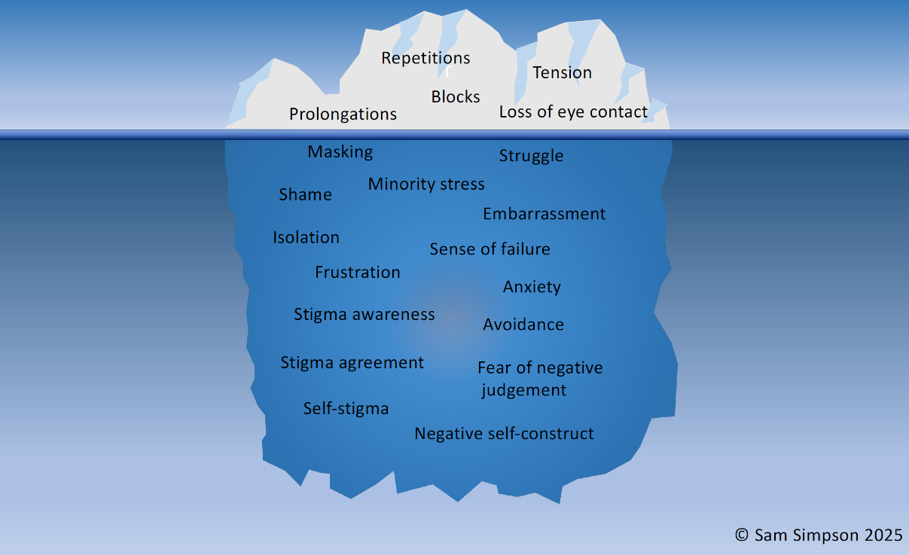

**Image courtesy of Sam Simpson, Redefining Stammering**

More recently, the water surrounding the iceberg has been linked to the speaking environment that impacts the experience of stammering. As shown in the iceberg below, the environment surrounding individuals who stammer can sometimes include one of stigma, discrimination, fluency privilege, ableism and microaggression.

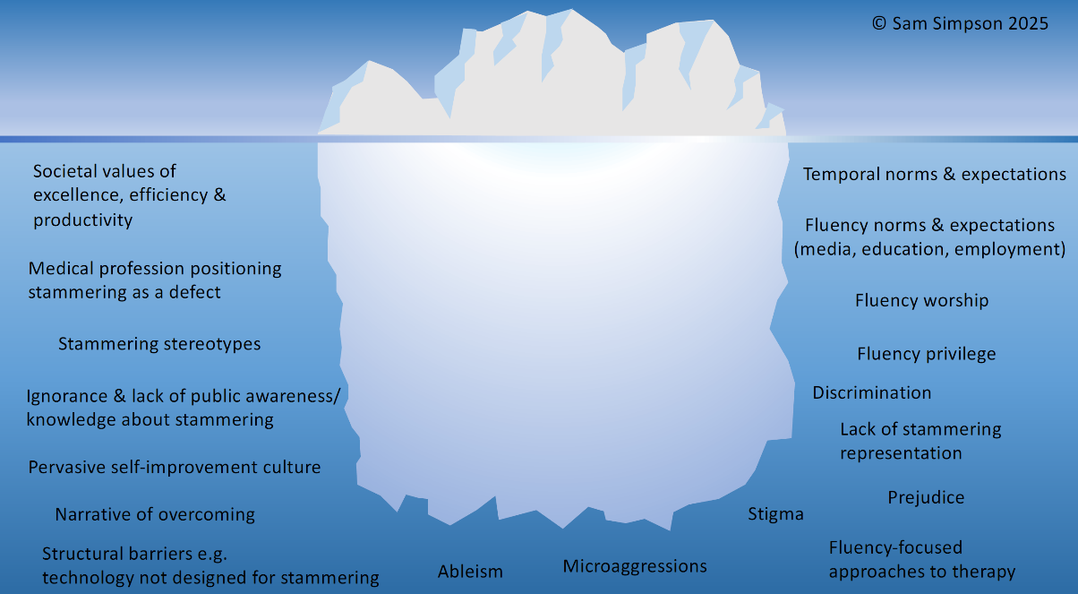

**Image courtesy of Sam Simpson, Redefining Stammering**

The third iceberg below envisages stammering-affirming shared world building. It illustrates the generative potential of stammering such as pride, sense of cultural heritage, belonging and community.

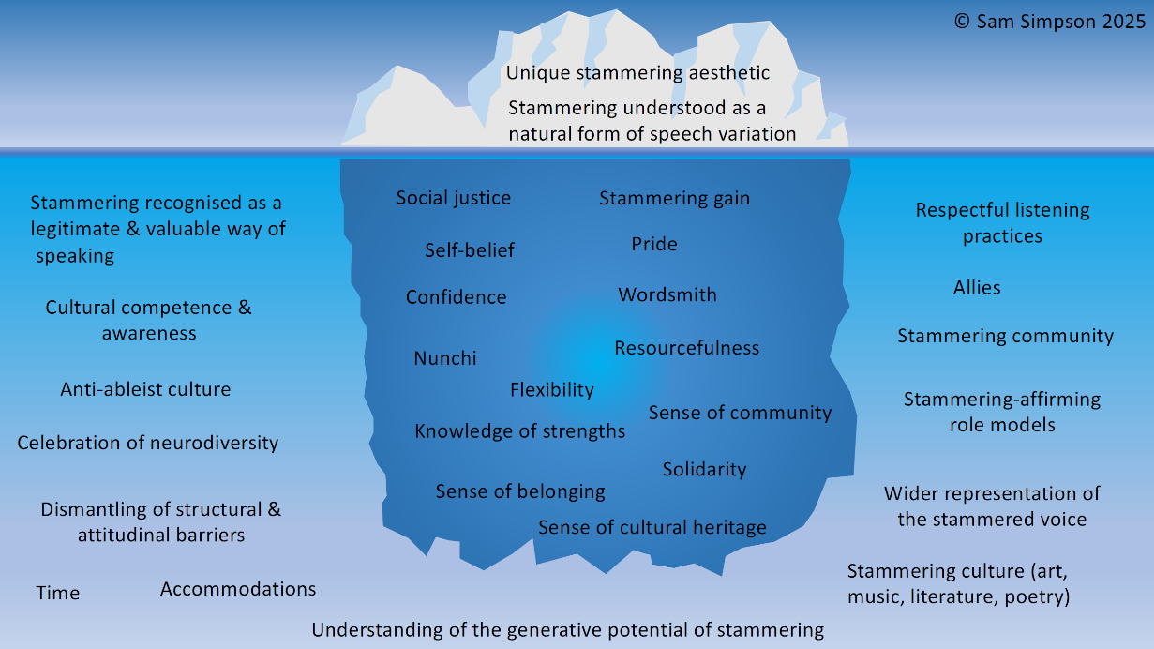

**Image courtesy of Sam Simpson, Redefining Stammering**

### 3.3 Speech

People who stammer experience variations in their speech which may be linked to certain situations or contexts. In a moment of stammering, people may repeat sounds, syllables and part-words, prolong sounds and block (Yairi et al., 2001;). As a reaction to moments of stammering, people may increase physical effort in their speech or elsewhere in their body (Tichenor et al., 2017). These visible aspects of stammering which are most evident or audible to the listener only represent part of the individual’s experience.

### 3.4 Thoughts and feelings

Some people who stammer may experience feelings such as frustration, embarrassment, fear and anxiety in relation to their speech. They may have negative thoughts about their stammering or themselves. (Tichenor & Yaruss, 2019a; Iverach et al., 2016; Boyle, 2015). These emotional and psychological consequences of stammering may arise because of the reactions or anticipated responses of the listener which could be either affirming or hostile (St Pierre, 2012). They may also arise due to the uncomfortable internal experience of a loss of speech control. The person who stammers may therefore attempt to mask their stammering by adopting escape behaviours such as strategies to avoid the possibility of stammering. A significant part of the experience of stammering therefore may be internalised.

### 3.5 Masking and variability

Traumatic social experiences and ableist messaging about stammering lead people to hide differences in their speech to protect themselves from stigma (Gerlack-Houck et al. 2022). People may use a range of strategies to conceal stammering (Sheehan, 1970) such as:

* using filler or starter sounds and words e.g. “um”, “like”
* switching a word on which stammering is anticipated to one that has a similar meaning or re-ordering words within a sentence
* holding back from contributing to a discussion
* not entering situations in which stammering is anticipated
* not forming relationships with certain people when negative consequences of stammering are anticipated.

Stammering naturally varies, with many individuals experiencing periods of more frequent or less frequent stammering (Tichenor & Yaruss, 2021). When a person who stammers feels a desire to speak but simultaneously wishes to conceal their identity as someone who stammers, they may experience an approach–avoidance conflict (Sheehan, 1970). Efforts to avoid stammering can become habitual, making them hard to break (Constantino, 2022) and often increasing the struggle with speech and increasing the duration of a moment of stammering.

### 3.6 Interiorised stammering

Whilst most people who stammer will have internalised aspects to their experience, some are able to and choose to conceal their stammering almost entirely using strategies to pass as a fluent speaker. This is termed interiorised stammering (Cheasman and Everard, 2013; Douglass et al., 2019) and may not be apparent to the listener. However, the internalised effort to conceal stammering is considerable. Some people may not be able to make sense of their experience of interiorised stammering as they may not have openly stammered for extended periods of time (Douglass et al., 2019). Some people might attempt to conceal stammering, passing as a fluent speaker by using speech modification strategies.

### 3.7 Developmental stammering

This refers to stammering that starts in childhood typically (but not always) before the age of four (Yairi and Ambrose, 2005) and can begin gradually over time or have a sudden onset. It can be:

* transient, lasting for only a certain amount of time
* episodic, where there are periods of little or no stammering as well as times when a child stammers frequently
* ongoing, where a child stammers more consistently over time albeit with some variability.

Stammering that begins in childhood may continue into adolescence and adulthood and evolve in its characteristics over time.

Some young children may be unaware of their stammering, while others might become aware and hesitate to speak or abandon their attempts to communicate. The psychosocial and emotional impact of stammering might increase for older school aged children and teens as they become more aware of differing responses and reaction to their speech within their everyday environments. They may increasingly attempt to conceal stammering which may be reflected in increased effort and speech tension.

### 3.8 Acquired stammering

This usually, but not always, refers to stammering that begins after childhood. Stammering may develop following neurological or psychological changes, (Ward, 2010) or be induced by medication (Fetterolf and Marceau, 2013). Stammering may also present as a feature of Functional Neurological Disorder.

Stammering that starts suddenly in adulthood with no known cause requires urgent medical referral, to rule out medical emergencies such as stroke, head injury or brain tumour.

### 3.9 Atypical stammering

This differs from what is usually observed in developmental stammering.

Developmental stammering typically occurs on the first sound or syllable of a word. Atypical stammering comprises repetitions or prolongations in the final part of the word or mid-syllable or between syllables (Plexico et al., 2010). Atypical stammering most commonly occurs in the communication of autistic individuals. (De Marchena & Eigsti, 2016; Engelhardt et al., 2017).

### 3.10 Stammering and intersectionality

Our social identity forms through adolescence into adulthood (Tatum, 2017). Stammering forms one aspect of social identity and intersects with various others such as race, gender, socioeconomic status and gender. The experience of stammering is therefore influenced by the intersection of different identities and the related overlapping of marginalisation or privilege. SLTs consider the individual identities of clients when offering services (Daniels & Boyle, 2023).

### 3.11 Stammering and other needs

Stammering may present in isolation or associated with other differences including:

* Attention Deficit Hyperactivity Disorder
* Autism (Altunel and Altunel, 2017; Preston et al., 2022)
* Cluttering (Scott, 2017; Van Riper, 1982; Van Zaalen-op’t Hof et al., 2009).
* Down Syndrome (Hokstad and Næss, K.B. 2024)

# Factors to consider

## What are the causes of stammering?

### 4.1 Developmental stammering

Causes of stammering are not well understood and remain an area for further research. However, current understanding is that it stammering is multifactorial in nature (Smith and Kelly, 1997).

The factors that could contribute to causes of stammering include:

* **Neurophysiological factors** with differences being shown in the brain structure and function in children and adults who stammer (Chang et al., 2019; Weber-Fox et al., 2013; Watkins, 2007)
* **Genetic factors** Drayna and Kang (2011) with approximately two-thirds of adults who stammer having a family member who also stammers (Bloodstein et al., 2021). This may be a factor to consider in predicting the persistence of stammering in children (Frigerio-Domingues et al., 2019).
* **Biological** sex with there being more males who continue to stammer than females.

Factors that influence stammering are:

* **Linguistic factors** whichmay be associated with the onset of stammering. These include delayed language development, developmental language disorder and phonological disorder. Children may also present with advanced language development or advanced vocabulary development when compared to their phonological skills. (Clark et al., 2015)
* **Environmental factors** may influence stammering. These include speaking demands, family dynamics, pace of life (Anderson et al., 2003) as well as societal attitudes and responses to stammering.
* **Individual temperament factors** including emotional regulation and reactivity, as well as behavioural disinhibition, can be associated with stammering (Jones et al. 2014)

### 4.2 Acquired stammering

There are three main causes of acquired stammering:

**Neurogenic** stammering results from a neurological event or disease (Lundgen et al. 2010; Ward, 2010). Stammering may start suddenly after stroke or traumatic brain injury or more gradually or intermittently in people who have neurological conditions such as Parkinson's Disease or Multiple Sclerosis.

**Functional** stammering which is associated with the brain starting to work in a different way. It presents as a response to life stress or psychological difficulty. It is more common in women than in men. It may co-occur with post-traumatic stress disorder, anxiety and depression, schizophrenia and Functional Neurological Disorder

**Pharmacogenic** stammering results as a side effect of prescribed medications including antipsychotics and neuroleptics.

## 4.3 Impact of stammering

Stammering may affect the ease with which an individual can communicate. Some people who stammer identify postive consequences of stammering. However, stigmatised perceptions of stammering and the experience of negative listener responses may lead to significant impact on self-esteem and quality of life for people who stammer.

### 4.4 How are people affected by stammering?

Studies outline the positive impact stammering can have on someone’s life such as increased sensitivity to others and stronger interpersonal and intimate relationships and an enrichment of communication (Boyle et al., 2019; Constantino 2019).

It has also been shown that over the lifespan, stammering can negatively impact quality of life in various ways (Norman et al., 2023) including mental health and wellbeing (Tichenor et al. 2023).

The stigmatisation of stammering in society affects individuals in multiple ways, including negative reactions from listeners and self-stigmatisation, where individuals who stammer internalise these negative perceptions, reinforcing feelings of stigma (Boyle, 2015).

These responses to stammering may reinforce an individual’s belief that they need to speak fluently and consequently use concealment strategies.

One research study suggests that efforts to speak fluently through concealment strategies or speech techniques, rather than speaking freely and spontaneously, may reduce quality of life (Constantino et al., 2020).

### 4.5 How does stammering affect children?

Children who stammer may:

* have more negative attitudes about speaking than children who don’t stammer as early as the preschool years (Vanryckeghem and Brutten, 2007)
* experience adverse listener reactions from their peers (Langevin et al., 2009).
* be bullied at school which negatively affects their happiness and wellbeing (Crichton-Smith 2002; Davis et al, 2002).
* experience social anxiety because of stammering (Iverach et al., 2016).

### 4.6 How does stammering affect parents?

* Parents of children who stammer may become distressed about how their child is speaking (Kelman et al 2012) and concerned about how it may impact their wellbeing and future. There is no evidence to suggest that stammering is caused by parents (Yaruss and Conture, 1995). However, in response to their child’s continued stammering, parents may alter their own interaction style such as using more turn-taking exchanges and more requests for information. (Kloth et al 1999).

### 4.7 How does stammering affect young people and adults?

Young people and adults who stammer may experience:

* micro-aggressive responses to stammering such as invalidation (e.g. “you don’t really stammer, I haven't noticed it) or being given advice about how to speak (e.g. “take a breath, slow down”) (Coalson et al., 2022).
* reduced educational outcomes through reduced participation. (Ribbler, 2006).
* disadvantage and discrimination due to stammering. It has been shown that this has a negative impact on employment outcomes such as reduced likelihood of being promoted and limits to earning capacity (Enderby & Emerson 1995, Hayhow 1999; Klein and Hood ,2004; McAllister et al, 2012; Gerlach et al. 2018).
* mental health difficulties including social anxiety disorder (Iverach et al. 2009; Craig and Tran, 2014).

# Role of speech and language therapy

Speech and language therapists play a key role in supporting children, young people and adults who stammer. People who stammer will have varied needs across their life and benefit from different types of support may involve speech and language therapy. People who stammer may seek support from speech and language therapy at transition points when speech demands change. This might be times such as starting secondary school or university or beginning a new job.

## 5.1 Models of disability

Historically, stammering was viewed through the **medical model** of disability. This impairment focused model situates the “problem” and responsibility to change with the individual. Aligned to this model, the role of the speech and language therapist is to support children, young people and adults who stammer to make changes in their speech so that they speak with greater ease and fluency. It is also likely to include work on thoughts/feelings around stammering to change the emotional response to stammering, develop resilience, reduce the person's avoidance behaviours and allow them to move towards their speaking goals.

More recently, stammering has been understood through the lens of the **social model** of disability (Bailey et al., 2015; Campbell et al., 2019; Constantino et al., 2022)). This model suggests that disability is shaped more by social, cultural, environmental, and political structures than by individual differences. It argues that these societal structures create barriers that contribute to the experience of disability. Such barriers include negative societal attitudes and behaviours towards stammering. Consequently, the SLT role has shifted to have an increased focus on confident and effective (rather than fluent) communication skills; valuing the authenticity of stammered speech and connecting with the broader community of people who stammer. Also, the role involves advocating for people who stammer, working with others to reduce barriers, promoting stammering-affirming practices and the reduction of stigma.

In summary, a social model-based approach takes a broader look at stammering within society, framing stammering as part of human communication diversity and moving towards stammering confidently.

## 5.2 Neurodiversity

There is clear evidence that stammering at its core is neurophysiological (Chang et al., 2019) and therefore can at least in part be attributed to neurological differences. The neurodiversity movement therefore has relevance to work with these client groups.This has emphasised a shift away from a binary view of "able-bodied" versus "disability" toward a more inclusive discourse that recognises and values both neurodivergent and neurotypical ways of being. Within this context, the role of the SLT would be one of affirming stammering, promoting an understanding of these speech differences and enabling the voice of these individuals to be heard as equals.

## 5.3 Reconciling different philosophies

When working with children, young people and adults who stammer, SLTs need to base practice on the current evidence base as well as consider the wider context of factors influencing the profession and the future directions of the stammering community. Reconciling the evidence with other theories and philosophies is challenging as there are potential tensions between these different perspectives.

Behavioural approaches are impairment focused and typically seek to reduce stammering to minimal levels. Approaches based on multifactorial or complex models of stammering aim to reduce the impact of the experience of stammering by focussing in on overt and covert aspects as well as improving interaction and the communication environment. Stammering affirming practice challenges ableist views and stigma surrounding stammering and does not involve working on speech change to reduce the frequency of stammering (Sisskin, 2023).

Clinical decision making can be especially challenging for SLTs who are yet to gain significant experience in working with these client groups and may require support and supervision from more specialist clinicians to support their confidence and skill development. However, irrespective of the approach taken, it is vital to keep the client at the centre, working in partnership to decide upon the most appropriate plan. It is also the role of all SLTs to undertake the following:

* Provide information to other professionals and to the public about stammering
* Provide information about and how to access local services and how to refer to them
* Educate other professionals such as Health Visitors, GPs, teachers and employers about stammering and the role of SLT in screening, assessing, identifying, supporting and providing therapy for people who stammer.
* Take a holistic, client centred approach to assessment and therapy
* Screen, assess, identify support and provide therapy as required
* Provide therapy that is evidence based
* ensure that there is focus on creating a strong therapeutic alliance with the client including with parents when working with children
* Refer to other services as appropriate
* Signpost to forms of support such as third sector e.g. STAMMA, Action for Stammering Children, 50 Million Voices, especially at the point of discharge from speech and language therapy services
* Ensure services are culturally and linguistically relevant
* Ensure the role of parents and families is an integral part of support and therapy for children who stammer
* Work with others such as teachers to ensure a supportive and inclusive environment
* support and promote awareness and acceptance of stammering.

# Statistics

The following data are derived from a range of research studies and so are based on different population samples.

## 6.1 Incidence and prevalence

* Research indicates that between 5% to 8% of children will stammer at some point during their development (Bloodstein, Bernstein Ratner & Brundage, 2021; Yairi and Ambrose 2013; Månsson, 2000)
* 95% of children who stammer will start to do so by the age of four (Yairi & Ambrose 2005)
* Approximately 80% of children who stammer will go on to develop fluent speech with 20% continuing to stammer in the longer term (Andrews et al., 1983; Bloodstein, 1995). Of children who stammer, one third will develop fluent speech within 18 months and one third within three years (Mansson, 2000; Yairi & Ambrose, 2005)
* At least 1% of school age children are likely to stutter at any one point in time. (Andrews et al., 1983; Bloodstein & Bernstein Ratner, 2008)
* A more recent U.S. study estimated that approximately 2% of children ages 3–17 years stutter (Zablotsky et al., 2019)
* Children with a family history of stuttering were estimated to be 1.89 times more likely to persist in stuttering (Singer et al., 2020)
* The lifetime prevalence of stammering is estimated to be between 0.72% (Craig et al., 2002) to 5% (Brocklehurst 2013)

## 6.2 Gender ratio

* Estimates of male to female ratio in stammering have been as high as 4:1 (St Louis and Hinzman, 1998)
* Younger age of onset may have smaller ratios in gender differences (Yairi and Ambrose, 2013)
* Males are 1.48 times more likely to persist in stammering than females (Singer et al., 2020)

## 6.3 Other needs

* Children who stammer are 5.5 times more likely to have another disabling developmental condition than children who do not stammer (Briley & Ellis, 2018, p. 2895)
* 40% of the children who stuttered exhibited disordered phonology compared to 7% of the matched controls (Louko et al., 1990)

# References TO BE ADDED