RCSLT Stammering overview (public page)

## DRAFT FOR CONSULTATION

April 2025

Information contained within this document is for consultation only and should not be shared outside of this.

**The information in this document is currently in development and has been shared as part of a consultation. If you are seeking guidance or information on this topic, please ensure you refer to final published content which can be found on rcslt.org.**

We appreciate any comments provided to us during the consultation, all of which will be reviewed by the working group within the context and scope of the project. We ask that, where possible and relevant, you accompany any counter arguments to statements made in the document with supporting evidence e.g. a research reference.

Members of the working group should not be contacted directly, and all feedback should be made through the assigned route e.g. via survey or project manager. Feedback made through unassigned routes or after the closing date will not be accepted or responded to.

Thank you for your support with this project.

Lorna Baxter, Senior Project Manager

[lorna.baxter@rcslt.org](mailto:lorna.baxter@rcslt.org)

# About this guidance

These web pages provide information for the public about stammering in children, young people and adults. The views of people with lived experience of stammering have been sought and used when writing them.

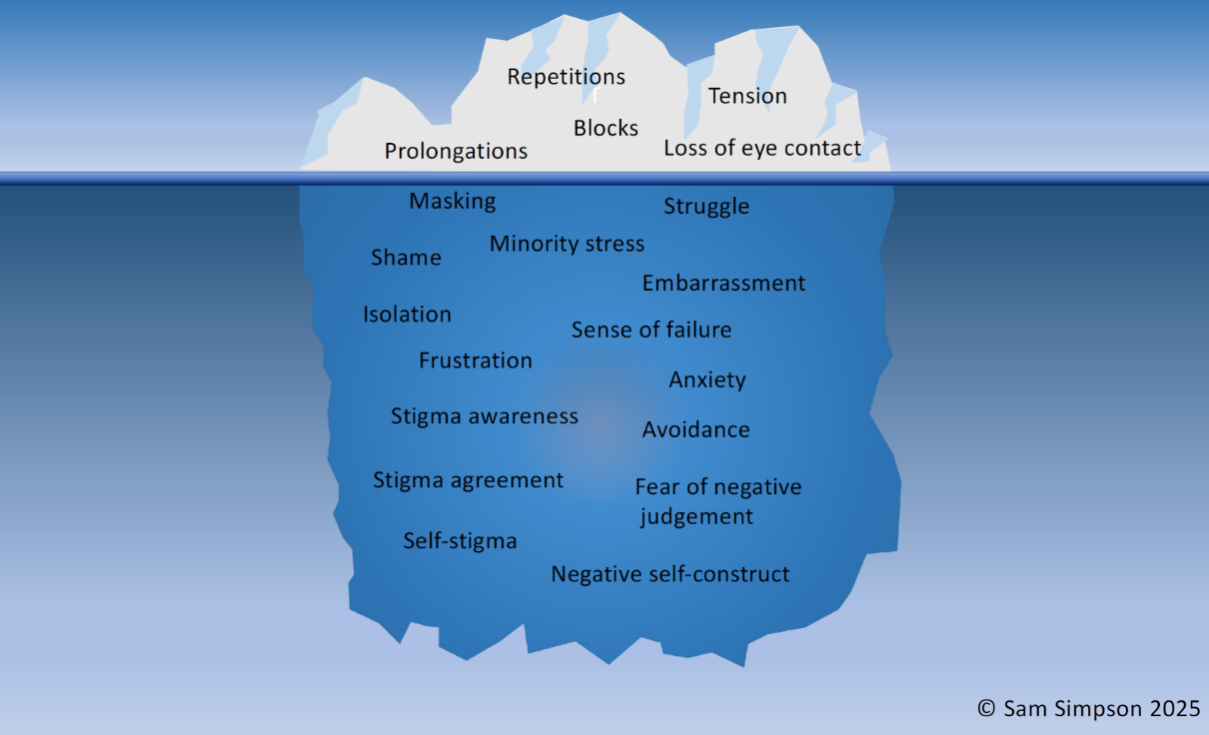

**Image courtesy of Sam Simpson, Redefining Stammering**

The analogy of an iceberg can be helpful in understanding stammering. The part above the surface refers to what you can directly see and hear as part of the stammering and the part below the surface relates to the thoughts, feelings and emotions that can sometimes go alongside stammering. In the water surrounding the iceberg there are the different speaking situations, people’s reactions to stammered speech and society’s attitudes to stammering.

# What is stammering?

Stammering, also known as stuttering, is a variation in someone’s speech. Stammering may come and go and increase and decrease at different times and in different speaking situations.

People who stammer may:

* repeat parts of a word or phrase
* prolong or stretch a sound, usually at the start of a word
* get stuck on a sound when speech is tense and effortful
* Use physical strategies to try to help speech such as tensing their face muscles or closing their eyes

Research has shown us that stammering is partly caused by a difference in the way which the brain is working. This means that, the way in which it functions or is firing is sometimes different.

Stammering may also be caused by genetics with stammering sometimes running in families.

Stammering may also be affected by other factors in children such as the development of other speech and language skills; their temperament or personality, their ability to regulate their emotions and resilience.

# How are people affected by stammering?

Some people who stammer may be comfortable with their speech and do not need help from speech and language therapy. Some have found that stammering has contributed positively to their lives. It has meant that they are part of a community with others who share the same differences in their speech. It may have led them to be interesting speakers who can hold an audience's attention, or to be good listenersand be empathic towards others who experience differences in their speech or other aspects of their lives.

Other people who stammer may experience negative feelings and thoughts about their speech such as embarrassment, fear, shame or frustration. This is a part of stammering that may be hidden from other people. These thoughts and feelings are often in part due to listeners’ unhelpful responses to stammering.

Some people who stammer may use different strategies to mask or reduce stammering. These include:

* Scanning ahead to see whether there is a word on which they might stammer coming up
* Switching a word where they may stammer for one with a similar meaning
* Using filler sounds and words such as “um”, “like” to keep the flow of speech going
* Holding back from speaking even when they have something important to say
* Staying away from certain situations.
* Feeling uncomfortable discussing stammering with others

# Stammering in children

As children learn to speak, they learn new vocabulary and how to put words together to make sentences. During the time in which their speech and language skills are developing rapidly, most children will have some non-fluency in their talking. They may hesitate or repeat a word as they are planning what they will say next. This is *different* to stammering.

Stammering is different from the non-fluencies related to speech and language learning because it is likely to also include

* repeated syllables or sounds e.g. “mum-mum-mummy", “m-m-m-mummy"
* prolonged sounds e.g. “mmmmmummy”
* blocks (when the sound is stuck e.g. “m------------mummy”)

## 4.1 What do we know about stammering in young children?

* stammering typically starts in early childhood, between the ages of two and four although sometimes at an older age
* between 5% and 8% of children will stammer at some point during their development
* around 80% of children who start to stammer, will not stammer into adulthood, (Andrews et al., 1983; Bloodstein, 1995).
* around 20% of the children who stammer will do so beyond the pre-school years.

Some children who stammer may go through school with no difficulty. However, for others, they may:

* experience difficulties in answering the register, experiencing fear in anticipation of when they need to respond as the teacher reads through the names
* experience difficulties in reading aloud in front of the class
* When being asked a question by the teacher in class
* receive negative responses to stammering from their peers including bullying.

## 4.2 Stammering in teenagers

The teenage years are a time of great change when young people are having to cope with hormonal and body changes associated with puberty and other life demands including:

* an increase in academic pressure such as presentations and oral exams
* an increase in peer pressure to conform
* An awareness of cultural norms and expectations relating to communication including for oral exams and interviews.
* a possible increase in negative listener reactions to stammering
* increased responsibility and autonomy
* increased self-awareness
* pressure or perceived pressure to speak fluently.

During this time, the experience of stammering is likely to change as young people respond to these demands in different ways. Some of these responses include:

* increased negative thoughts and feelings about stammering
* increased avoidance including of social relationships
* social anxiety
* decreased participation in class
* possible disruptive behaviour.

# Stammering in adults

Many adults who stammer will have some differences in their speech which are noticeable to others. But many will also have a significant part of their stammering which may not be seen or heard by others. They may mask, hide or choose to avoid moments of stammering if they find them too uncomfortable or don't others to see or hear the stammering. This can be extremely hard work. However, a significant part of their stammer may be hidden. Thoughts and feelings about speaking and masking may not be obvious to other people.

Stammering may impact people in different ways across their life. In particular, people might notice changes in their speech and how they feel about it at certain transition points. These might include starting a new course, job, or relationship or becoming a parent.

## 5.1 Interiorised stammering

Some people are able to conceal their stammering almost entirely and choose to do so. This could mean that the person orders food/drink that they don't want because it is easier to say, avoid certain jobs because they are anxious about using the phone and never speak to their family/friends about their speech

They present as a fluent speaker almost all of the time. This is called interiorised stammering. Using these strategies all the time is stressful and can have a negative impact on someone's mental health and wellbeing.

Many adults who stammer are successful at work and have strong social relationships. However, stammering may impact some people in the following ways:

* social anxiety
* reduced employment opportunities and earning capacity
* limited opportunities to form relationships

## 5.2 Stammering starting in adulthood

Most people who stammer start to do so in childhood. Occasionally, people begin to stammer as an adult. This is due to one of the following causes:

* **Neurological** reasons such as sudden damage to the brain such as a stroke or due to a progressive condition such as Multiple Sclerosis or Parkinson’s Disease
* Functional Neurological Disorder which is when the body’s neurology begins to function differently and there is a difficulty with how the brain receives and send information for a range of functions. Stammering may be one feature of this.
* **Psychological** reasons often as a response to a traumatic event or to extreme stress
* **Medication** related reasons. Some medications such as those that treat psychotic illness may lead to a change in speech.

# How can speech and language therapy help?

## 6.1 What is speech and language therapy?

Speech and language therapists provide support, therapy and care for people of all ages who are experiencing difficulties resulting from speech, language or communication differences. Speech and language therapists work in the NHS, in schools and in private practice. Many therapists who work in private practice are also members of the [Association of Speech and Language Therapists in Independent Practice](https://asltip.com/).

There is no charge for speech and language therapy offered by the NHS. Private speech and language therapists typically charge for their time on an hourly basis. All speech and language therapists must be registered with the Health and Care Professions Council. This registration ensures they adhere to established codes of ethics and practice, guaranteeing that the services they provide are safe and of high quality.

The way in which speech and language therapy is provided may differ across the four nations of the UK. However, the overall aim remains the same: to support people who stammer to live fulfilling lives.

## 6.2 How do speech and language therapists support people who stammer?

Speech and Language Therapists play a key role in supporting children, young people and adults who stammer. Using specialist skills, they work directly with the individual client and with others in their life to ensure that the speaking environment is as supportive as possible. For children this involves working with parents, carers and school. Speech and language therapists support young people and adults to be able to advocate for themselves

## 6.3 What to expect from speech and language therapy

**Referral / Requests for assistance** is when someone wishes to seek support and advice for a child, young person or adult as there is concern about how their speech, language or communication is affecting their everyday life.

You can access speech and language therapy in the following ways:

**For children**

* A referral / request for assistance by a Health professional including GP or Health Visitor
* A referral / request for assistance by nursery or school
* A direct referral / request for assistance by the parent / carer to the local speech and language therapy service may be possible
* Parents can ask school to make referral / request for assistance
* Direct contact with a private speech and language therapist to request assistance

**For young people**

* A referral / request for assistance by a GP or by the school
* Parents can ask the school to make a referral / request for assistance
* A direct referral / request for assistance by the parent / carer to the local speech and language therapy service may be possible
* Direct contact with a private speech and language therapist to request assistance

**For adults**

* A referral by your GP
* A self-referral to the local speech and language therapy service
* Direct contact with a private speech and language therapist to request assistance

### 6.4 What happens next?

When someone who stammers has been referred to speech and language therapy, they should expect confirmation that:

* The referral has not been accepted and a referral needs to be made to another service OR
* The referral has been accepted
* The waiting time for assessment will be confirmed.
* You will be offered some general advice while you are waiting and be given information about other organisations that can offer support. (Add link to resources page)

### 6.5 Assessment

Speech and language therapists assess the needs of children, young people and adults who stammer. This involves gathering background information about the client and their speech as well as observing and listening to how they are communicating. Assessment includes consideration of the client’s level of awareness and insight around stammering and what this means for them.

In collaborative discussion with the adult client or parent and child, the SLT establishes whether support for stammering is the individual’s main need. Where it is, the speech and language therapist will offer information to help clients understand more about stammering and the things that might and might not help. The therapist will ask the client about their best hopes from therapy and discuss realistic expectations. They will also signpost people to other available support and opportunities to be a part of the stammering community.

When it is believed the client would benefit from support other than speech and language therapy, the SLT will either refer to another professional and / or signpost to other support services including charities.

### 6.6 Therapy

The SLT will explain the different options for therapy and support the client to select the best option for their needs and preferences. These options will be informed and guided by research findings together with information that has been gathered by SLTs through their practice. The SLT will explain what the realistic/potential outcome of this therapy will be and how many therapy sessions will be offered. Enough sessions should be offered to ensure therapy is effective.

**Children**

When providing therapy for children who stammer, it is important that this involves the parent / carer and sometimes other people who are involved in the child’s life such as the extended family or teachers. Therapy aims to make sure that the child has a supportive communication environment, parents are confident to support their child, and that the child can communicate freely whether or not they stammer. Therapy may involve working mainly with the parent/carer or also directly with the child.

**Young people**

Therapy for young people supports them to be effective communicators. Therapy in groups can be beneficial as it allows the young person to feel part of a community as well as benefiting from learning alongside peers.

Therapy may involve working with the family and school to ensure there is a supportive communication environment. Young people are supported to advocate for themselves.

Speech and language therapists also work with teachers to ensure that when needed, adjustments are made to classroom speaking activities and exams.

Therapy may sometimes involve working directly on speech change.

**Adults**

Therapy will involve working in partnership with the client to jointly work towards goals for change.

It will involve supporting the client to gain an in-depth understanding of their stammering and their responses to it. It will include exploring the influence speaking environments and society have had on the impact of their stammering. Therapy may involve working towards reducing concealment of stammering and moving towards less effortful, easier communication.

Therapy may sometimes involve working directly on speech change.

### 6.7 Advice

As part of their role, SLTs can offer general advice about stammering. This includes advice:

* To parents about how to support their child whilst they are waiting for an appointment
* To all other professionals (e.g. GP, Health Visitor, teacher) about whether to refer to speech and language therapy
* To school and nursery staff about how to create a stammering friendly environment
* To schools, colleges and universities about seeking reasonable adjustments for certain activities such as oral exams and presentation assessments
* To people who stammer about how to find organisations such as charities that offer support.

### 6.8 Training

Speech and language therapists can provide training about stammering to make ensure the creation of supportive speaking environment. This training can be offered to:

* school and education workforce
* health professionals
* employers

# Information for health professionals including GPs and health visitors

Health professionals including general practitioners and health visitors play a vital role in referring children, young people and adults to speech and language therapy. Delayed referral can have negative impact on therapy outcomes and the individual’s emotional wellbeing. Stammering is highly variable and so you may not hear any stammering during your consultation; it is important to trust the person's description of their experience and refer based on this.

## 7.1 Early childhood (2-5 years)

* Whilst many children will not stammer into adulthood, an SLT assessment can help to determine the level and type of support and advice that a parent / carer might need
* Early intervention is advised for children who stammer
* Childhood stammering is variable over time and comes and goes from one day to the next. If you see a child on one occasion and they are not stammering, this does not mean that the child does not stammer. It is important to ask parents about stammering across different times and situations in order to gain a more complete picture Referral is important when:
* the child is aware of stammering and is responding negatively such as becoming frustrated or avoiding talking OR
* parents are concerned about their child’s speech

## 7.2 Older children, teens and adults

Referral to SLT is recommended when the child, young person, parent or adult:

* expresses concern OR
* is impacted socially, academically or professionally OR
* is trying to conceal stammering by masking or reducing OR
* is experiencing anxiety associated with stammering.

Referral for psychological support may also be appropriate when social anxiety or other mental health need is having a significant impact.

**NOTE:** If an adult or young person has recently started to stammer for the first time, this could have a neurological or psychological cause requiring further, immediate investigation.

# Information for education professionals including early years practitioners, teachers, lecturers

Within the education setting, some speaking activities may be particularly challenging for students who stammer. There are several useful resources available to support students who stammer and education staff. [**link to resources]**

A referral to or request for assistance from speech and language therapy is indicated when:

* when stammering is impacting learning or social interaction
* when the student is also experiencing anxiety or other mental health condition
* when the child, young person or adult is requesting support

**NB:** speech and language therapists can offer training to help you to support students who stammer.

# Resources

## RCSLT resources

* [Where speech and language therapists work](https://www.rcslt.org/speech-and-language-therapy/where-slts-work/)
* Position statement for stammering [insert link]

# Organisations and networks

These organisations provide support to people who stammer as well as opportunities to network.

STAMMA

* This UK charity offers resources and information on stammering; training for organisations; groups, networks and clubs for adults, parents and children; workshops for adults who stammer; and supports those who have been treated poorly or unfairly because they stammer.
* Website: [www.stamma.org](http://www.stamma.org)
* Freephone helpline: 0808 802 0002
* [Webchat](mailto:Webchat) service
* Email support at [help@stamma.org](mailto:help@stamma.org)

Action for stammering children

* This UK charity focuses on supporting children and young people and offers resources for SLTs, parents, and schools.
* Website:[www.actionforstammeringchildren.org](http://www.actionforstammeringchildren.org)
* It includes the Stambassadors Network which helps children and young people find out about the wide range of careers people who stammer have: <https://actionforstammeringchildren.org/stambassadors/>
* Support hub : <https://support.actionforstammeringchildren.org/hc/en-gb>

50 Million Voices

* This international network and UK charity has the goal of transforming the world of work for people who stammer.
* Website: <https://www.50millionvoices.org/>

The following organisations prove specialist therapy for people who stammer:

The Michael Palin Centre for Stammering

* This specialist centre offers evidence-based therapy approaches.
* Website: <https://michaelpalincentreforstammering.org/>
* Helpline: 020 3316 8100

The Fluency Trust

* Offers residential intensive courses for young people who stammer, combining therapy with outdoor pursuits.
* Website*:* <https://thefluencytrust.org.uk/>

Talking Out

* Offers face to face, online and residential groups for people who stammer and their families
* Website: [Talking Out Ltd](https://talkingout.co.uk/)

City Lit

* This Adult Education college offers in person and online therapy courses for people 18+.
* Website: [citylit.ac.uk](https://www.citylit.ac.uk)

The Scottish Stammering network

* The dedicated Scottish charity supporting and empowering those who stammer.
* Website: <https://www.scottishstammeringnetwork.org/>